**Exercise - Build a basic Power Automate flow in Microsoft Copilot Studio**

**Section 1: Prepare the cancellation topic**

1. Navigate to the Contoso Support copilot you've been working with and open the **Topics** page from the navigation menu.
2. Open the **Check Order Status** topic and select the **Variables** menu.
3. Choose **OrderNumber**, change the **Usage** from **Topic** to **Global**, and **Save** the topic.

[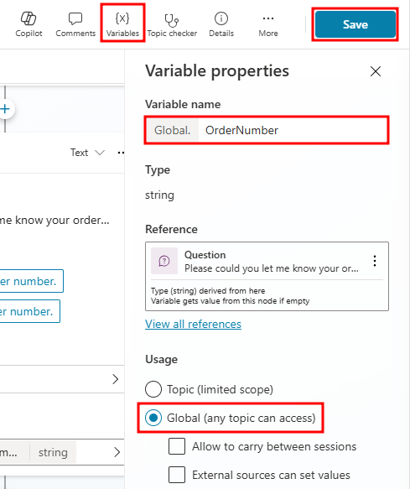](https://learn.microsoft.com/en-us/training/modules/build-flows-chatbot-online-workshop/media/order-number.png#lightbox)

**Tip**

**Global** variables can be used between topics, while **Topic** variables can only be referenced within a single topic.

1. Next, navigate to the **Order Cancellation** topic created in previous exercises.
2. Add a **Question** node below the **Trigger** node, and in the message box, enter: Can you provide me with an email address to send a confirmation email to?
3. Under **Identify**, choose the **User's entire response** option. Next, select the **Save your response as** variable, and create a new variable named **UserEmail**.
4. Next, modify the message node to say: Your order has been cancelled, and a confirmation email has been sent.
5. Now, between the **Question** and **Message** nodes, select the **+** symbol and under **Call an action** select **Create a flow**. This process will open a new Power Automate flow in a separate tab.

[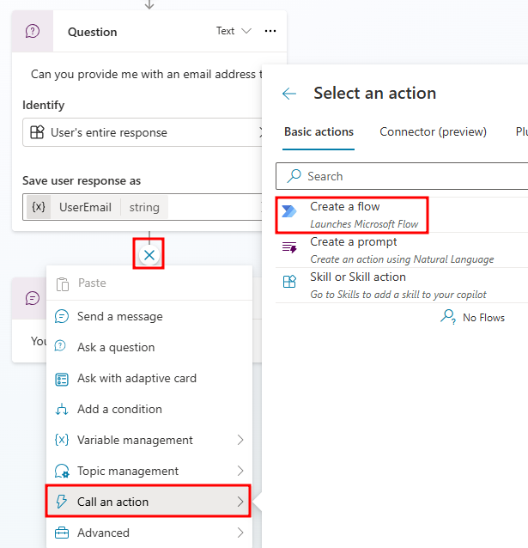](https://learn.microsoft.com/en-us/training/modules/build-flows-chatbot-online-workshop/media/create-flow.png#lightbox)

**Section 2: Create your Power Automate flow**

Next, create your Power Automate flow by following these steps:

Notice the scaffolding that occurs when you create a new Power Automate flow by using Microsoft Copilot Studio. Two nodes are automatically created. The first node is the input that the flow expects from Microsoft Copilot Studio. You don't need to set inputs within this action; however, a common input would be a user utterance or variable, such as the country/region specified in the example. The second node is the output that a maker can return to Microsoft Copilot Studio after the flow retrieves or completes the operations within the automation.

**Important**

Make sure that you keep the Microsoft Copilot Studio pre and post actions at the top and bottom of your Power Automate flow to ensure that the data can be passed to and from Power Automate from Microsoft Copilot Studio.

1. In the new flow window that opens, select the **Run a flow from Copilot** action. Then, select **+ Add an input**.

[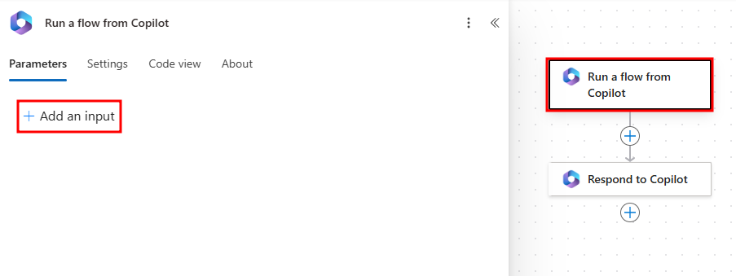](https://learn.microsoft.com/en-us/training/modules/build-flows-chatbot-online-workshop/media/add-input.png#lightbox)

1. Under **Choose the type of user input** select **Text**.
2. Next, change the name of **Input** to UserEmail.

[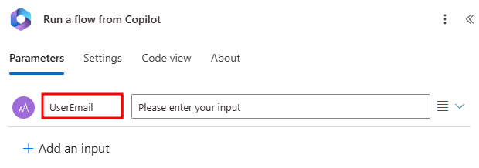](https://learn.microsoft.com/en-us/training/modules/build-flows-chatbot-online-workshop/media/input-email.png#lightbox)

1. Select **+ Add an input** and add another **Text** input. Name this input OrderNumber.

[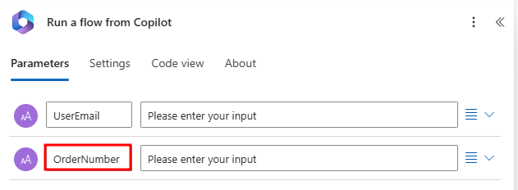](https://learn.microsoft.com/en-us/training/modules/build-flows-chatbot-online-workshop/media/input-order.png#lightbox)

1. Then, click the **+** button below the **Run a flow from Copilot** action and select **Add an action** to add a new action.

[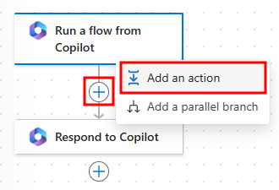](https://learn.microsoft.com/en-us/training/modules/build-flows-chatbot-online-workshop/media/add-action.png#lightbox)

1. Enter Email in the search bar and then select **Send an email (V2)** under **Office 365 Outlook**.

[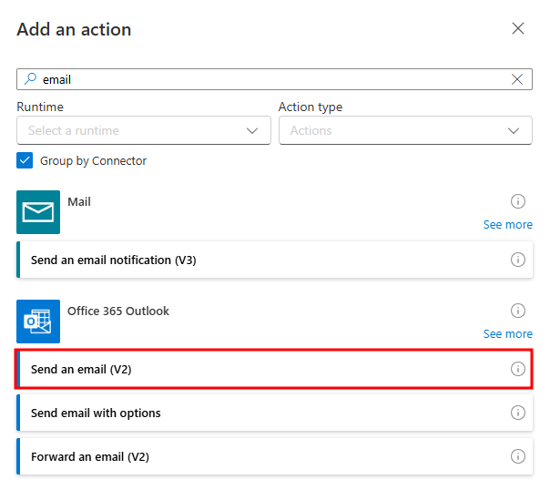](https://learn.microsoft.com/en-us/training/modules/build-flows-chatbot-online-workshop/media/send-email.png#lightbox)

1. If you do not already have a connection set, you will need to create one. Select **Sign in** within the **Send an email (V2)** action window.
2. After setting up your Outlook connection, the **Send an email (V2)** action window prompts you to input a **To** address. To use the input variable we created previously, select **Switch to Advanced Mode**.

[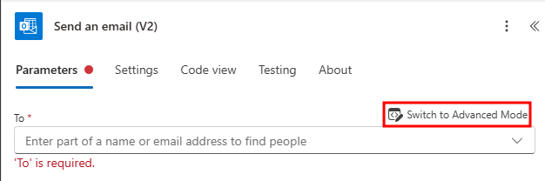](https://learn.microsoft.com/en-us/training/modules/build-flows-chatbot-online-workshop/media/advanced-mode.png#lightbox)

**Dynamic content** is real-time data, and in this scenario, the **UserEmail** would be the data passed from Microsoft Copilot Studio that you set up at the beginning of the topic and requested from your user.

1. Click in the **To** field and select the **Lightning bolt** icon to the right to pull up the **Dynamic content** menu. This will fill the **To** address with what the user responded with.

[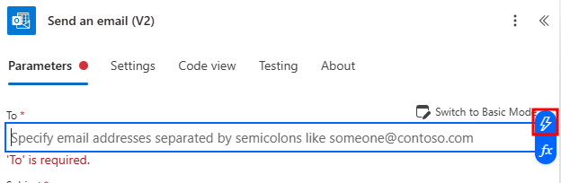](https://learn.microsoft.com/en-us/training/modules/build-flows-chatbot-online-workshop/media/dynamic-content.png#lightbox)

1. In the **Dynamic content** menu, select **UserEmail** under **Run a flow from Copilot**.

[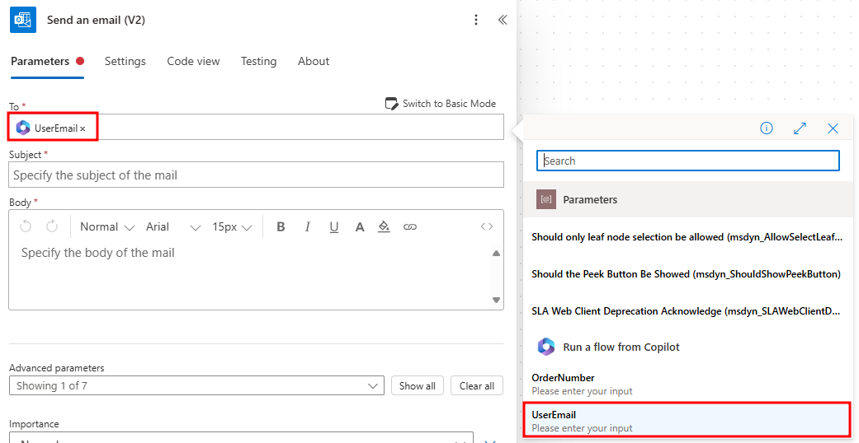](https://learn.microsoft.com/en-us/training/modules/build-flows-chatbot-online-workshop/media/dynamic-email.png#lightbox)

1. In the **Subject** field enter: Order Cancellation.
2. In the **Body**, type The order following by **OrderNumber** from **Dynamic content** has been cancelled. Thank you for choosing Contoso!

[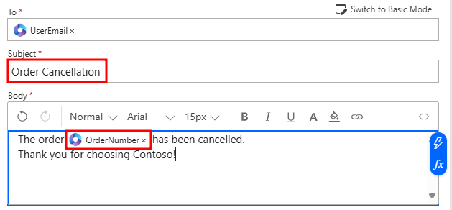](https://learn.microsoft.com/en-us/training/modules/build-flows-chatbot-online-workshop/media/email-body.png#lightbox)

**Note**

Make sure you add a space before and after dynamic content when used in a sentence.

1. The flow is almost complete. You need to rename it before you can move on. Select the title Run a flow from Copilot in the top-left corner and rename it to Cancellation Confirmation, as shown in the following screenshot.

[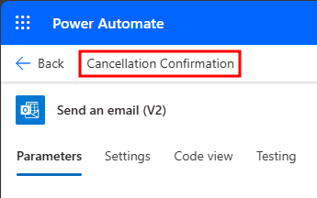](https://learn.microsoft.com/en-us/training/modules/build-flows-chatbot-online-workshop/media/save.png#lightbox)

1. Select **Save** in the top-right corner on the flow in Power Automate to ensure that it saves. Wait a moment until the green banner appears, indicating success.

You completed your work in Power Automate. Next, you switch to Microsoft Copilot Studio.

**Section 3: Connect a Power Automate flow with Microsoft Copilot Studio**

In this task, you connect a Power Automate flow with Microsoft Copilot Studio.

1. Go back to your **Order Cancellation** topic in Microsoft Copilot Studio, and add a new node between the **Question** and **Message** nodes. Select **Call an action**. Your new Power Automate flow displays in the list. From the list, select **Cancellation Confirmation**.

[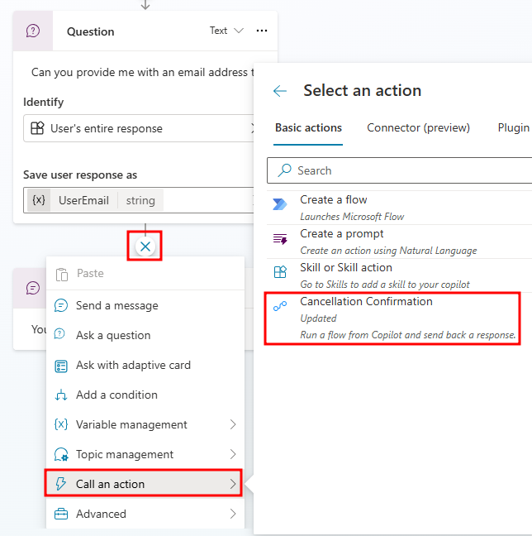](https://learn.microsoft.com/en-us/training/modules/build-flows-chatbot-online-workshop/media/add-flow.png#lightbox)

**Note**

If the flow does not show up, save the topic and refresh the page.

1. When you select the **Cancellation Confirmation** flow, a new **Action** node is created automatically. If the flow requires an input, it requests that you select the value. Because the flow that you created in the previous steps has the inputs of **UserEmail** and **OrderNumber**, you need to add these inputs into the Power Automate action by selecting the variable that the value is stored in.
2. Select **Enter or select a value** and then select the **Global.OrderNumber** variable for **OrderNumber (String)**, and **Topic.UserEmail** for **UserEmail (String)**.

[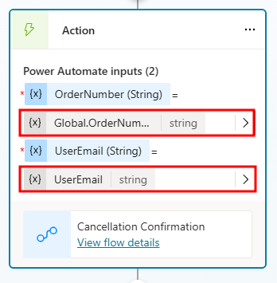](https://learn.microsoft.com/en-us/training/modules/build-flows-chatbot-online-workshop/media/action-inputs.png#lightbox)

1. To end the conversation, select the **Add node** button below the **Message** node. Select **Topic management** and then choose **End conversation**.
2. **Save** your topic using the button found in the top right corner of the screen and then use the testing panel to test the flow.
3. Start the conversation by saying Order status, then when asked for an order number enter ORD-102938. When asked what to do with your order, select **Cancel**. When asked for an email address, enter an email address you have access to.
4. The first time the flow you created is called, you will need to add permissions to connect to the email server. Select **Connect** in the test window to create a connection.

[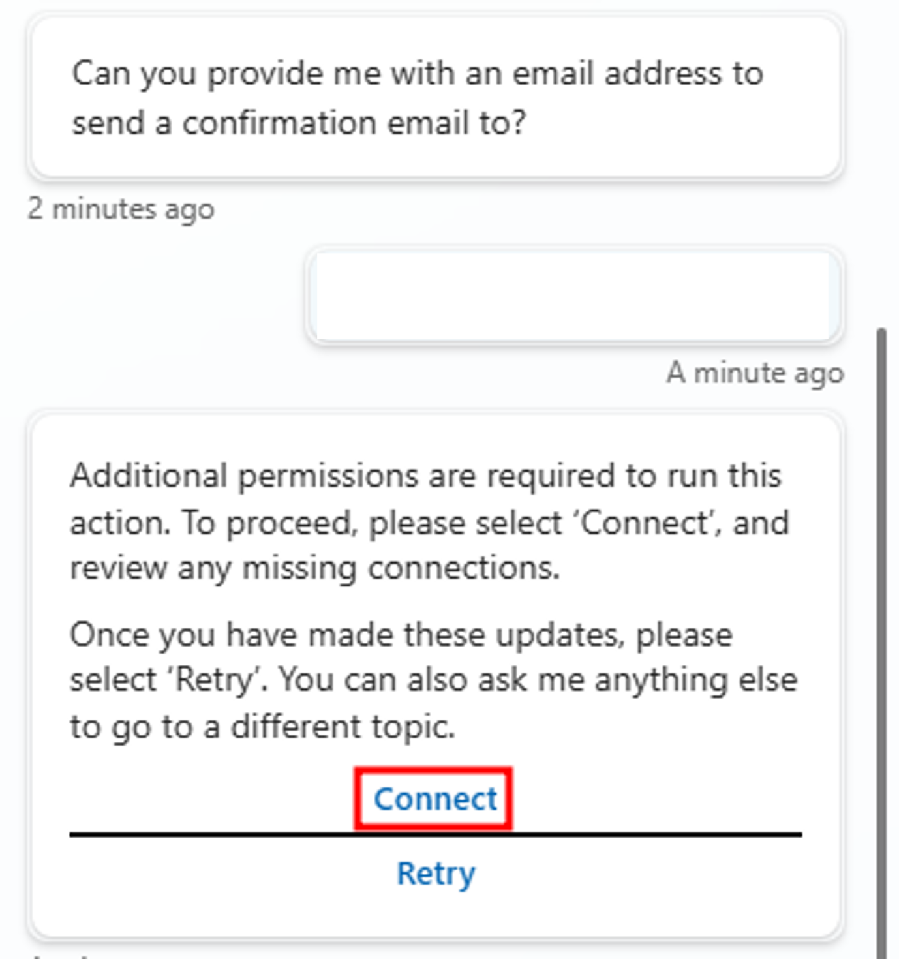](https://learn.microsoft.com/en-us/training/modules/build-flows-chatbot-online-workshop/media/connect.png#lightbox)

1. A new tab will open showing the copilot's connections. To the right of the **Cancellation Confirmation** flow, select **Connect** under **Status**.

[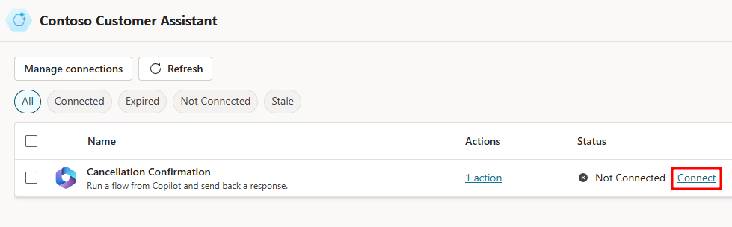](https://learn.microsoft.com/en-us/training/modules/build-flows-chatbot-online-workshop/media/new-connection.png#lightbox)

1. Make sure there is a checkmark next to the **Office 365 Outlook** connection in the **Create or pick connections** window, and select **Submit**.

[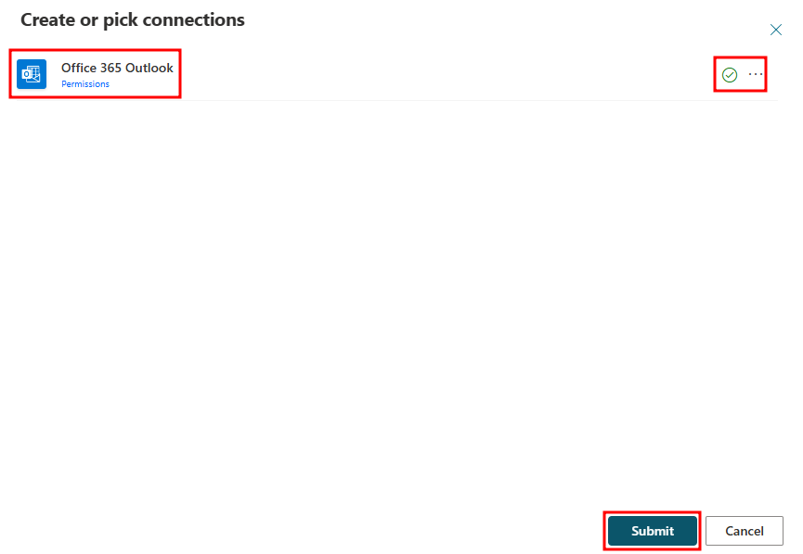](https://learn.microsoft.com/en-us/training/modules/build-flows-chatbot-online-workshop/media/submit.png#lightbox)

1. Now with the connection set, go back to the copilot test pane, and select **Retry**.

[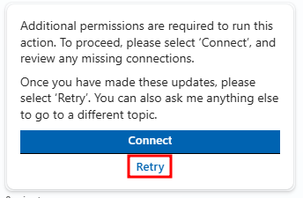](https://learn.microsoft.com/en-us/training/modules/build-flows-chatbot-online-workshop/media/retry.png#lightbox)

1. After selecting **Retry**, the email flow will run and send you a confirmation email with the order number.

[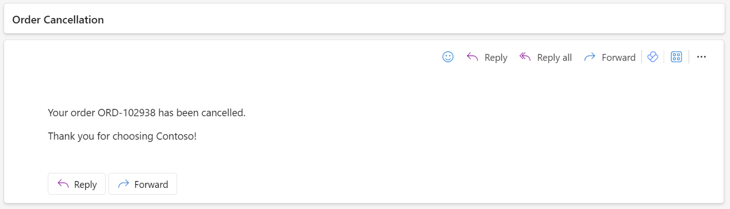](https://learn.microsoft.com/en-us/training/modules/build-flows-chatbot-online-workshop/media/email-sent.png#lightbox)

You successfully created a Power Automate flow in Microsoft Copilot Studio that uses user-submitted data to populate a confirmation email.